**1)explain oops concept??**

Encapsulation

Abstraction

Inheritance

Polymorphism

**2)types of inheritance?**

1)single level inheritance

2)multilevel inherritence

3)hirarichal

4)hybrid

5)multiple

**3)Constructor overloading?**

Its name is same as class name but in differ in parameter

**4)What is ddl and dml?**

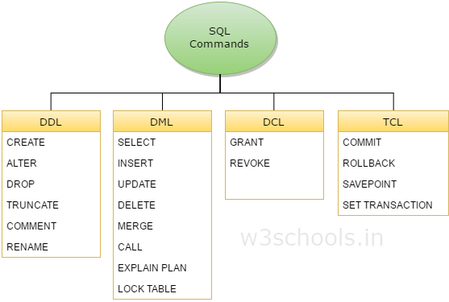

**5)Differnce b/w DDL and DML commands?**

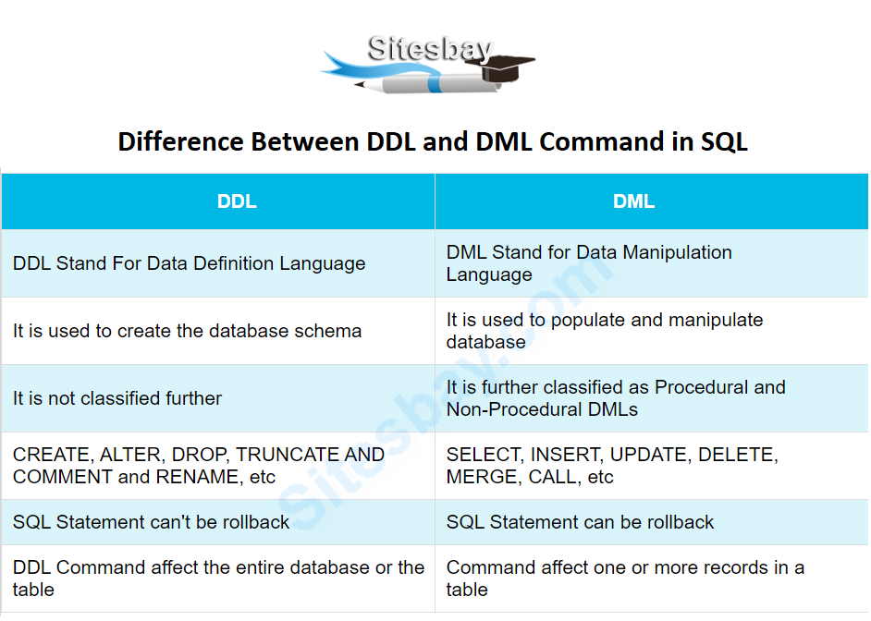

**6 what is sdlc?**

There are some different phase in sdlc

1)requirement

2)designing

3)development

4)testing

5)deployment

6)maintainence

Different type of model

1)waterfall model

2)agile model

**7)whatis normalization?**

It is a process of organizing the data in the database

Minimize the redundancy from a relation and set of relation

It divide the larger table to smaller table and link them

**8)types of normalization?**

1nf: eliminate the groups

2nf:elimate the function dependency

3nf:eleminate the transitive dependency

Bcnf:Boyce codd normal form

**9)what is cloud computing?**

**10)what is access modifier?**

Public

Private

Protected

Default

**11)what is the use of system.out.println?**

Print values to console

**12)explain public static void main(String args[])?**

Public is the access modifier which every one can access

Static is the keyword.it is access by class name. it load at a time of class load.

Void is not return any thing

Main is the first method where the program run

String args is array of string . it pass array of string argument

**13) For loop?**

Iterate over a list of item

**14)what is java?**

Object oriented programming language

**15)difference b/w break and continue??**

Break : exit the loop

Continue: skip the current iteration

**16)what are constructor?**

It is used to initialize the object

It name same as class name

It is two type?

1)Default

2)parameterized

**17) different type of joins?**

1)inner join

2)full join

3)left join

4)right join

**18)what are the trigger?**

It is special type of stored procedure that automatically run when an event occur in database. Dml occur event inset , update , delete

**19)difference b/w 2nf and 3nf?**

2nf->it must n’thave partial dependency

3nf->it must n’t have transitive dependency

**20)Explain final keyword?**

Final is used to apply the restriction on class, method,variable

Final class can’t be inherited

Final class can’t be override

Final variable can’t be changed

**21)explain overloading and overriding?**

Method overloading->

1)it is a compile time polymorphism

2)It occur with in the class have same name multiple method

Method overriding->

1)it is a run time polymorphism

2)it performed in 2 class with inheritance relationshaip method for same name and argument also

**22) what is the use of finally block**?

Finally block put the important codes such as clean up code

Ex-

1)closing the file

2)closing the connection

It execute the code exception handled or not

**23)is multiple inheritance possible in java?**

Yes, not possible for class but possible for interface

**24) ACID properties in DBMS?**

A->atomicity

C->consistency

I->isolation

D->durability

<https://www.geeksforgeeks.org/acid-properties-in-dbms/>

23)difference b/w drop /truncate/delete?

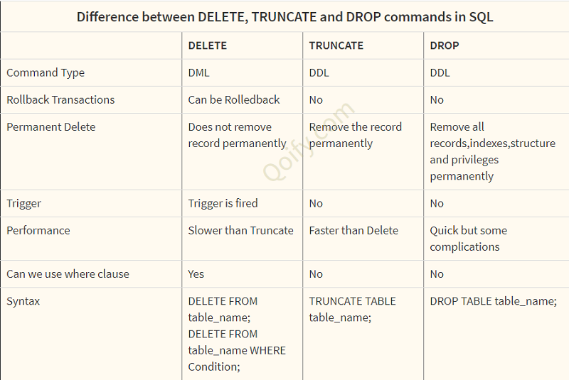

24)Differnce b/w having and where clause?

Where ->

1)where clause used in select update delete

2)where clause implement in row operation

3)where clause can not contain aggregate function

Having->

1) Having clause used in selectstatement

2)having clause implement the column operation

3)having clause can contain aggregate function

26)type of polymorphism?

27)final?

28)finally?

29)super?

30)what is exception?

It is an evnt terminate/disrupt the normal flow of program at runtime

31) difference b/w array and linklist?

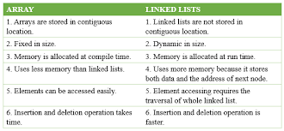

32)what is indexing?

It is used in database .

By using indexing retrival is more fast

33)what is exception handling?

<https://www.javatpoint.com/exception-handling-in-java>

34)split function?

35)static method?

it call when class is loaded.

It will be accessible to all the object in class

It belong to class not instance of a class

It share the same memory location

36)what is this keyword?

This keyword refer to current object in method or constructor

37)can we override static method?

No

38)how can we declare abstract method?

Abstract method are only declaration is there but no definition

39)linear search and binary search?

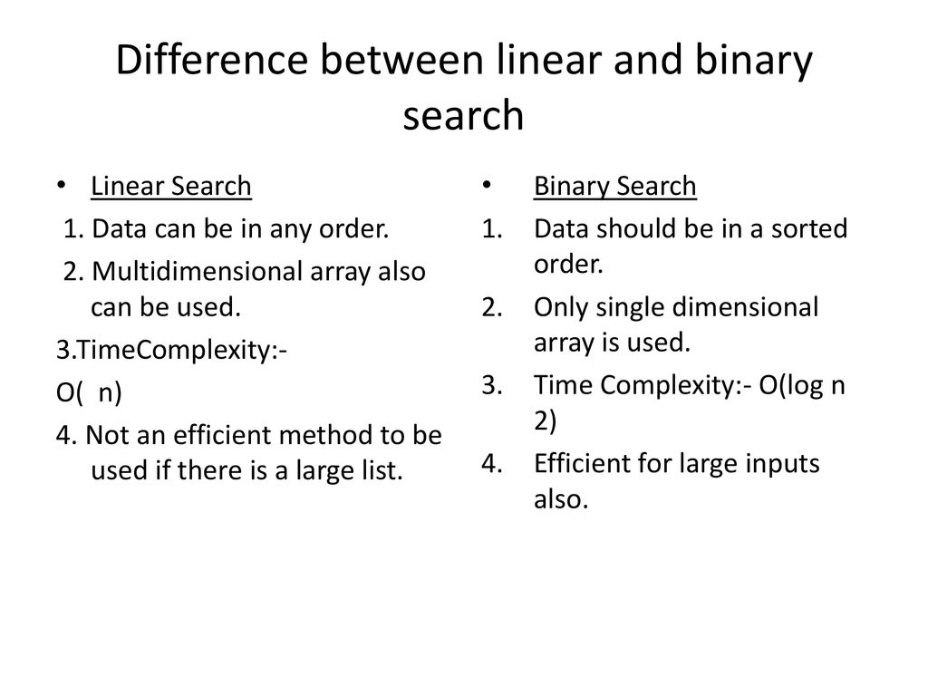

40) Differnce b/w abstract class and interface?

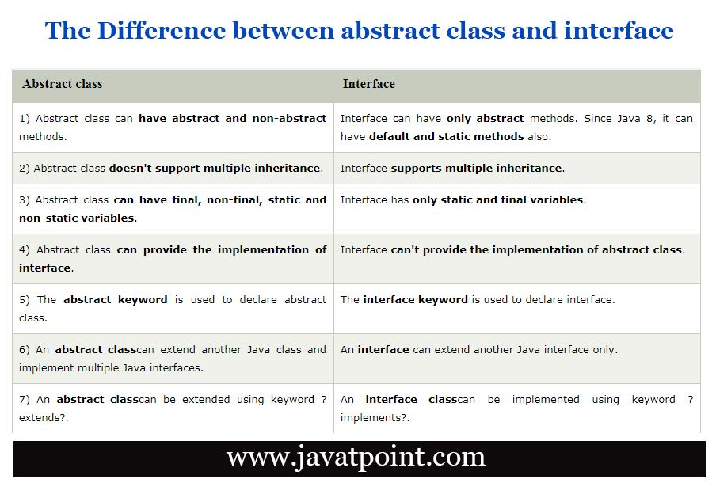

41)difference b/w singleton and prototype bean?

Singleton-> only one instance is created for a single bean definition and same object shared for each request

Prototype-> anew instance will be created for a single bean

42) what is jagged array?

43) why java is not purely object oriented language?

44)difference b/w equal and ==?

45)explain thread life cycle?

46)difference b/w final,finally, finalize?

47)difference b/w jdk,jre,jvm?

48)why java is called a platform independent language?

49)difference b/w early and late binding?

50)what is over riding?

51)what is overloading?

52)what is pure virtual function?

53)what are the operator that can not be overloaded?

56)what is abstract class and how many instance of this class can be created?